Supporting Information
Screening and Validation: AI-Aided Discovery of Dipeptidyl Peptidase-4 Inhibitory Peptides from Hydrolyzed Rice Proteins

Cheng Cheng, Huizi Cui, Xiangyu Yu, Wannan Li *
Key Laboratory for Molecular Enzymology and Engineering of Ministry of Education, School of Life Sciences, Jilin University, Changchun, 130012, China
* Corresponding author.
E-mail addresses: liwannan@jlu.edu.cn (W. Li).
Table S1.Oryza sativa glutelin and prolamin data from NCBI
NO. | Protein type | Protein ID | Protein Annotation
1 | Oryza sativa Japonica Group | CAA29507.1 | glutelin, partial
2 | Oryza sativa Japonica Group | ABL74552.1 | glutelin
3 | Oryza sativa Japonica Group | ACT31355.1 | glutelin, partial
4 | \ |  | glutelin
5 | Oryza sativa | KAB8090568.1 | hypothetical protein EE612_015772
6 | Oryza sativa | KAB8087153.1 | hypothetical protein EE612_011104
7 | Oryza sativa | KAB8086667.1 | hypothetical protein EE612_010114
8 | Oryza sativa | KAB8083624.1 | hypothetical protein EE612_005886, partial
9 | Oryza sativa | KAB8082662.1 | hypothetical protein EE612_004636
10 | Oryza sativa | KAB8082442.1 | hypothetical protein EE612_004322
11 | Oryza sativa | KAB8082169.1 | hypothetical protein EE612_003960
12 | Oryza sativa | BAA92322.1 | protein disulfide isomerase, partial
13 | Oryza sativa Japonica Group | XP_066164194.1 | glutelin type-B 1-like
14 | Oryza sativa Japonica Group | XP_015624148.1 | glutelin type-B 1-like
15 | \ | Q0ILQ6.1 | Protein glutelin precursor
16 | Oryza sativa Japonica Group | NP_001410566.1 | ras-related protein Rab5A
17 | Oryza sativa Japonica Group | BAF29772.1 | Os12g0472500
18 | Oryza sativa Japonica Group | BAF29598.1 | Os12g0283400
19 | Oryza sativa Japonica Group | BAF25378.1 | Os09g0476800
20 | Oryza sativa Japonica Group | BAF23982.1 | Os08g0482300
21 | Oryza sativa Japonica Group | BAH90862.1 | Os01g0111900
22 | Oryza sativa Japonica Group | BAF11132.1 | Os03g0188500
23 | Oryza sativa Japonica Group | BAF05612.1 | Os01g0644600
24 | Oryza sativa Japonica Group | BAF05442.1 | Os01g0607000
25 | Oryza sativa Japonica Group | BAT17103.1 | Os12g0472500
26 | Oryza sativa Japonica Group | BAS82698.1 | Os03g0188500
27 | Oryza sativa Japonica Group | BAS78514.1 | Os02g0453600
28 | Oryza sativa Japonica Group | BAS74462.1 | Os01g0761800, partial
29 | Oryza sativa Japonica Group | BAS73393.1 | Os01g0644600
30 | Oryza sativa Japonica Group | BAS73078.1 | Os01g0607000
31 | Oryza sativa Japonica Group | BAS70025.1 | Os01g0111900
32 | Oryza sativa Japonica Group | BAG98842.1 | unnamed protein product
33 | Oryza sativa Japonica Group | BAG98429.1 | unnamed protein product
34 | Oryza sativa Japonica Group | BAG98159.1 | unnamed protein product
35 | Oryza sativa Japonica Group | BAG97108.1 | unnamed protein product
36 | Oryza sativa Japonica Group | BAG96020.1 | unnamed protein product
37 | Oryza sativa Japonica Group | BAA11130.1 | prolamin
38 | Oryza sativa Japonica Group | BAA11129.1 | prolamin

Table S2.Expasy——Peptide Cutter Simulated Hydrolysis Results
Enzyme Type | Main Recognition Site in Protein Sequence（from Expasy） | Number of Peptides | Total Number of Peptides
Trypsin | K*、R* | 236 | 638
Pepsin(PH>2) | *F、*Y、*W | 394 | 638
Proteinase K | A、E、F、I、L、T、V | 478 | 638
Chymotrypsin-high specificity (C-term to [FYW], not before P) | F*、Y*、W* | 290 | 638
Chymotrypsin-high specificity (C-term to [FYW], not before P)+Proteinase K | F*、Y*、W*、A、E、F、I、L、T、V | 473 | 638
Trypsin+ Pepsin(PH>2) | K*、R*、*F、*Y、*W | 513 | 638
Note: Enzyme Type represents the enzymes used to simulate hydrolysis, including single and mixed enzymes; Recognition Site in protein sequence（from Expasy）denotes the amino acid site of cleavage，X*means the enzyme cuts at C-terminal respectively,*X means the enzyme cuts at N-terminal respectively,X means no specific direction; Number of peptides indicates the number of peptides hydrolyzed by each enzyme; Total number of peptides refers to the total number of peptides after removal of the same peptide.

Table1. Comparison table of MMPBSA data of the five systems from amber
PEPTIDE | PPPPPPPPA | PPPSPPPV | PPPPPY | CPPPPAAY | IPI
TOTAL | -856.8347±1.5956 | -804.8789±2.9361 | -626.2052±1.3591 | -904.4586±1.0153 | -130.5087±0.8054
VDWAALS | -14.9755±1.6419 | -31.63±1.2437 | -23.3941±1.5081 | -9.9879±1.8452 | -35.7948±0.7933
EEL | -176.9902±4.9936 | -123.8245±4.033 | -111.4327±8.8749 | -89.0932±14.6396 | -54.1497±3.4142
EPB | 171.3293±4.5814 | 126.2392±4.0975 | 112.0730±6.4848 | 88.9622±14.3216 | 71.3043±3.5419
DELTA G gas | -191.9657±6.1111 | -155.4545±4.1207 | -134.8268±9.3420 | -99.0811±15.9587 | -89.9445±3.7115
DELTA G solv | 171.3293±4.5814 | 126.2392±4.0975 | 112.0730±6.4848 | 88.9622±14.3216 | 71.3043±3.5419
DELTA TOTAL | -20.6364±1.6548 | -29.2153±0.9191 | -22.7538±3.2340 | -10.1189±1.7491 | -18.6402±0.7969
Note: The table summarizes MM/PBSA-derived energy components for five peptide systems (PPPPPPPA, PPPSPPPV, PPPPPY, CPPPPAAY, IPI), including total system energy and decomposed terms: Van der Waals interactions (VDWAALS), Electrostatic en-ergy (EEL), Polar solvation energy (EPB), Gas-phase binding free energy (DELTA Ggas, ΔGgas), Solvation free energy (DELTA Gsolv, ΔGsolv), and Total binding free en-ergy (DELTA TOTAL, ΔTOTAL). All values are reported in kcal/mol.
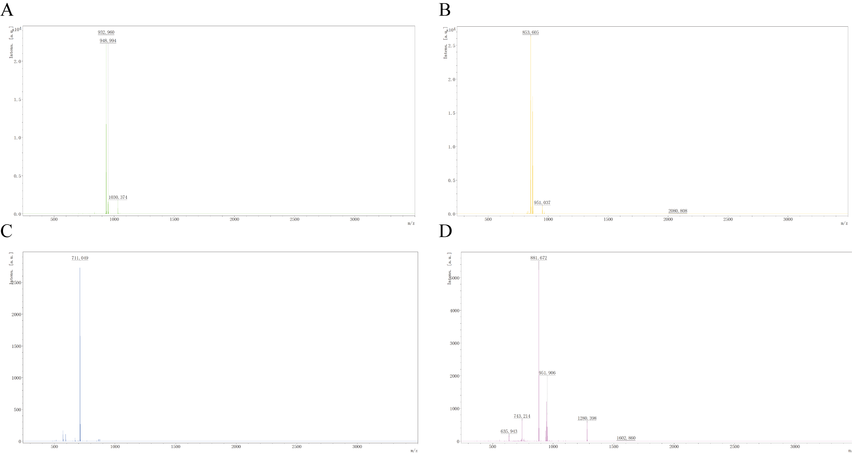
Figure S1. MALDI-TOF-MS of four synthetic peptides. PPPPPPPPA (A), PPPSPPPV (B), PPPPPY (C), and CPPPPAAY (D).

